Physical Education

The Big Questions

What makes me want to do more and be more?

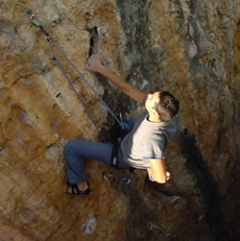

How can we show respect for others with individualized beliefs and abilities?

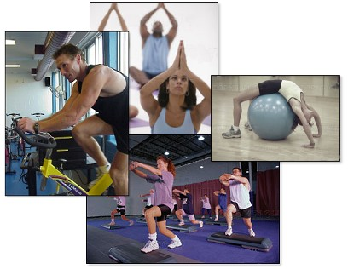

How can we get involved in our school and community to help influence others?

How can we increase our level of physical fitness so that we can have more success in sports, activities, and quality of life?

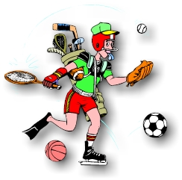

Who defines “Me?”

